Introduction to Elastic Load Balancing

**SPL-68 Version 2.0.18**

© 2024 Amazon Web Services, Inc. or its affiliates. All rights reserved. This work may not be reproduced or redistributed, in whole or in part, without prior written permission from Amazon Web Services, Inc. Commercial copying, lending, or selling is prohibited. All trademarks are the property of their owners.

Note: Do not include any personal, identifying, or confidential information into the lab environment. Information entered may be visible to others.

Corrections, feedback, or other questions? Contact us at [*AWS Training and Certification*](https://support.aws.amazon.com/#/contacts/aws-training).

**Overview**

This lab provides you with an introduction to Elastic Load Balancer. It covers creating and testing a Network Elastic Load Balancer. When the lab is launched you are provided with two web servers in two different Availability Zones. In the lab you will create a Network Elastic Load Balancer and use the two Web Servers as targets. You will then test the functionality of the load balancer in different scenarios.

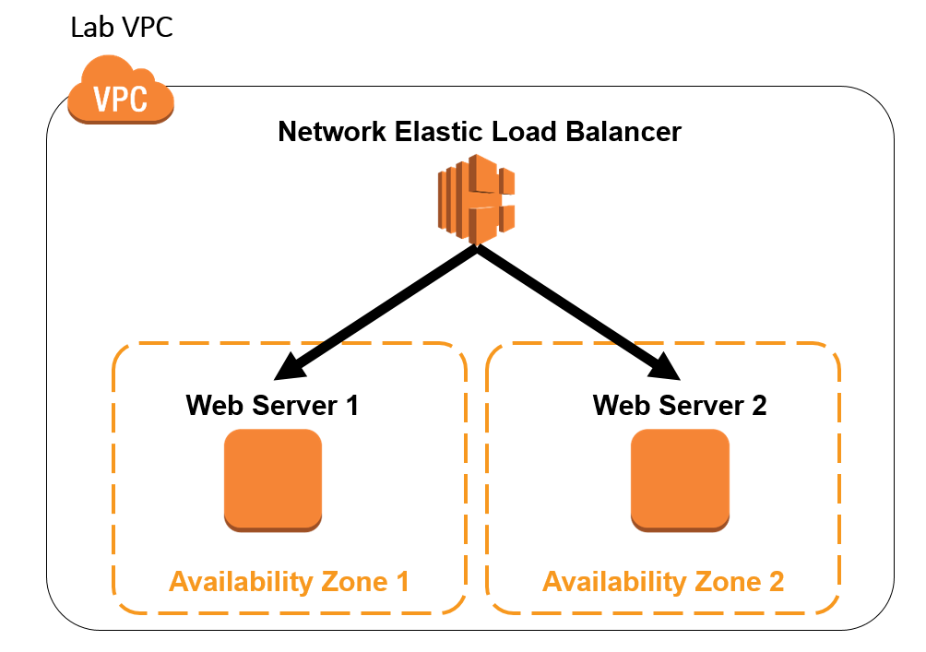

OBJECTIVES

By the end of this lab, you will be able to do the following:

* Test connectivity to two web servers that reside in two different Availability Zones
* Create a Network Load Balancer and use the two web servers as Elastic Load Balancer targets
* Test the default functionality of your load balancer
* Enabled Cross-Zone load balancing and test how your load balancer behaves
* Test the behavior of your load balancer during a failure of one of your web servers
* Test the behavior of your load balancer after your web server has recovered from the failure

PREREQUISITES

This lab requires:

* Access to a computer with Microsoft Windows, Mac OS X, or Linux (Ubuntu, SuSE, or Red Hat).
* A modern internet browser such as Chrome or Firefox.

DURATION

This lab requires approximately *60* minutes to complete.

ICON KEY

Various icons are used throughout this lab to call attention to different types of instructions and notes. The following list explains the purpose for each icon:

* **Additional information:** Information of special interest or importance.
* **Note:** The note icon specifies important hints, tips, guidance, or advice.
* **Caution:** Calls attention to information of special interest or importance. Failure to read the note does not result in breaking the service or losing any data, but could result in the need to repeat certain steps.
* **Task complete:** A conclusion or summary point in the lab.

**Start lab**

1. To launch the lab, at the top of the page, choose **Start lab**.

**Caution:** You must wait for the provisioned AWS services to be ready before you can continue.

1. To open the lab, choose **Open Console**.

You are automatically signed in to the AWS Management Console in a new web browser tab.

**WARNING:** **Do not change the Region unless instructed.**

COMMON SIGN-IN ERRORS

**Error: You must first sign out**

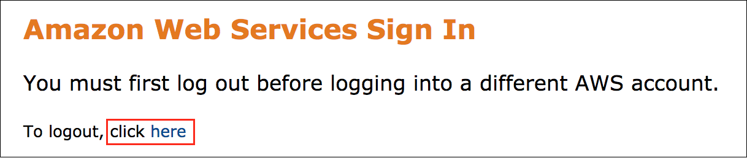

If you see the message, **You must first log out before logging into a different AWS account:**

* Choose the **click here** link.
* Close your **Amazon Web Services Sign In** web browser tab and return to your initial lab page.
* Choose **Open Console** again.

**Error: Choosing Start Lab has no effect**

In some cases, certain pop-up or script blocker web browser extensions might prevent the **Start Lab** button from working as intended. If you experience an issue starting the lab:

* Add the lab domain name to your pop-up or script blocker’s allow list or turn it off.
* Refresh the page and try again.

SERVICES USED IN THIS LAB

**Amazon Elastic Load Balancer**

An Amazon Elastic Load Balancer (Amazon ELB) is a service that automatically distributes incoming application traffic across multiple Amazon EC2 instances. It enables you to achieve even greater fault tolerance in your applications, seamlessly providing the amount of load balancing capacity needed in response to incoming application traffic. Elastic Load Balancing detects unhealthy instances within a pool and automatically reroutes traffic to healthy instances until the unhealthy instances have been restored.

Customers can enable Elastic Load Balancing within a single Availability Zone or across multiple zones for even more consistent application performance. Elastic Load Balancing can also be used in an Amazon Virtual Private Cloud (VPC) to distribute traffic between application tiers.

**Network Load Balancer**

Network Load Balancer operates at the connection level (Layer 4), routing connections to targets (Amazon EC2 instances, microservices, and containers) within Amazon VPC, based on IP protocol data. Ideal for load balancing of both TCP and UDP traffic, Network Load Balancer is capable of handling millions of requests per second while maintaining ultra-low latencies. Network Load Balancer is optimized to handle sudden and volatile traffic patterns while using a single static IP address per Availability Zone. It is integrated with other popular AWS services such as Auto Scaling, Amazon EC2 Container Service (ECS), Amazon CloudFormation, and AWS Certificate Manager (ACM).

**Task 1: Test Access to Your Web Servers**

In this task, you connect to each of your web servers over HTTP. This proves that your web servers are serving a web page. These EC2 instances were created in the CloudFormation template when you started the lab.

1. To the left of these instructions, copy the value of **WebServer01** to your clipboard, then:

* Paste the value into a new browser tab
* Press **Enter**

**Note:** You see a page that displays *Test Website - EC2 Instance 1*

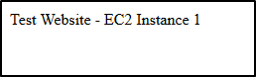

1. To the left of these instructions, copy the value of **WebServer02** to your clipboard, then:

* Paste the value into a new browser tab
* Press **Enter**

**Note:** You see a page that displays *Test Website - EC2 Instance 2*

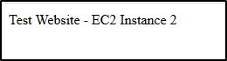

**Task complete:** You have successfully verified both the Web Servers.

**Task 2: Create an Elastic Load Balancer**

1. In the **AWS Management Console**, use the AWS search bar to search for **EC2** and then choose the service from the list.
2. In the left navigation pane, choose **Load Balancers**.
3. Choose **Create load balancer** .

**Additional information:** A load balancer serves as the single point of contact for clients. The load balancer distributes incoming traffic across multiple targets, such as Amazon EC2 instances. This increases the availability of your application.

1. On the **Select load balancer type**, below **Network Load Balancer**, choose **Create** .

**Additional information:** A Network Load Balancer functions at the fourth layer of the Open Systems Interconnection (OSI) model. It can handle millions of requests per second. After the load balancer receives a connection request, it selects a target from the target group for the default rule. It attempts to open a TCP connection to the selected target on the port specified in the listener configuration.

1. On the **Create Network Load Balancer** page, configure:

* **Load balancer name:**

myELB

* **VPC:** Select ***Lab VPC*** from the drop-down menu
* **Mappings:** Select ***both Availability Zones***
* **Security groups:** Select ***ELBSecurityGroup*** from the drop-down menu

1. In the **Listeners and routing** section, choose Create target group  .

**Additional information:** You register targets for your Network Load Balancer with a target group. By default, the load balancer sends requests to registered targets using the port and protocol that you specified for the target group.

1. In the **Basic configuration** section, configure:

* **Target group name:**

lb-targets

* **Protocol:** TCP
* **VPC:** Make sure ***Lab VPC*** is selected

1. Expand  **Advanced health check settings**, then configure:

* **Healthy threshold:**

2

* **Interval:**

10 seconds

**Additional information:** The load balancer sends a health check request to each registered target every HealthCheckIntervalSeconds seconds, using the specified port, protocol, and ping path. It waits for the target to respond within the response timeout period. If the health checks exceed the threshold for consecutive failed responses, the load balancer takes the target out of service. When the health checks exceed the threshold for consecutive successful responses, the load balancer puts the target back in service.

**Note:** Since you’ve set the **Healthy threshold** to *2* and the interval to *10 seconds*, it takes at least *20 seconds* for your instance to report a *healthy* status. By default, each load balancer node routes requests only to the healthy targets in its Availability Zone.

1. At the bottom of the screen, choose **Next** .
2. In the **Available instances** section, select *both EC2 instances*.
3. Choose **Include as pending below** .

**Caution:** Make sure you choose **Include as pending below** .

1. Choose **Create target group** .
2. Navigate to the tab that you were using to create your load balancer.
3. In the **Listeners and routing** section, choose the  refresh button.
4. From the drop-down list, select the **lb-targets** target group that you created earlier.

* Review your load balancer configuration
* Choose **Create load balancer**

1. Choose **View load balancer** .
2. In the **Details** tab of your load balancer, copy the DNS name to your text editor.

**Note:** Your DNS name should look similar to *myELB-4e009e86b4f704cc.elb.us-west-2.amazonaws.com*

1. In the left navigation pane, choose **Target Groups**.
2. Select **lb-targets** Target group.
3. Choose the **Targets** tab.
4. Wait for your EC2 instances to have a status of  healthy .

**Note:** You may have to  refresh the screen to see the changes. Here are the possible values for the health status of a registered target:

* **initial:** The load balancer is in the process of registering the target or performing the initial health checks on the target
* **healthy:** The target is healthy
* **unhealthy:** The target did not respond to a health check or failed the health check.
* **unused:** The target is not registered with a target group, the target group is not used in a listener rule for the load balancer, or the target is in an Availability Zone that is not enabled for the load balancer.
* **draining:** The target is deregistering and connection draining is in process

**Task complete:** You successfully created the Network Load Balancer and registered the Targets in the Target group.

**Task 3: Test Your Load Balancer**

TEST THE DEFAULT FUNCTIONALITY

1. In a new browser tab, paste the DNS name and then press **Enter**.

**Note:** You should see the HTML page for one of your EC2 instances.

1. Refresh  the page a few times.

Notice that the same EC2 instance page is displayed.

**Additional information:** With Network Load Balancers, cross-zone load balancing is disabled by default. After you create a Network Load Balancer, you can enable or disable cross-zone load balancing at any time.

**Additional information:** Cross-zone load balancing distributes traffic evenly across all targets in the Availability Zones enabled for the load balancer.

TEST CROSS-ZONE LOAD BALANCING FUNCTIONALITY

1. In the **AWS Management Console**, in the left navigation pane, choose **Load Balancers**.
2. In the **Details** section, choose the **Attributes** tab.
3. Choose **Edit** and then configure:

* Enable  Cross-zone load balancing
* Choose **Save changes**

1. Wait a minute or two.
2. Return to the browser tab that you used to access your load balancer.
3. Refresh  the page a few times.

**Task complete:** You should see that your network load balancer now directs you to both of your EC2 instances.

DISABLE CROSS-ZONE LOAD BALANCING FUNCTIONALITY

1. In the **AWS Management Console**, in the left navigation pane, choose **Load Balancers**.
2. In the **Details** section, choose the **Attributes** tab.
3. Choose **Edit** and then configure:

* Disable  Cross-zone load balancing
* Choose **Save changes**

1. Wait a minute or two.
2. Return to the browser tab that you used to access your load balancer.
3. Refresh  the page a few times.

**Task complete:** You should see that your network load balancer is now only serving pages from one of your instances.

**Task 4: Test Your Load Balancer During a Failure**

TEST LOAD BALANCER DURING A FAILURE

1. In the **AWS Management Console**, in the left navigation pane, choose **Instances**.
2. Select the **EC2 instance** that is currently serving you the web page.
3. From **Instance state** drop-down list, select **Stop instance**.
4. Choose **Stop** .
5. Wait a minute or two.
6. Return to the browser tab that you used to access your load balancer.
7. Refresh  the page a few times.

**Task complete:** You see that that your load balancer now displays the web page for your other instance.

TEST LOAD BALANCER AFTER RECOVERING FROM A FAILURE

1. In the **AWS Management Console**, in the left navigation pane, choose **Instances**.
2. Select the **EC2 instance** that you stopped earlier.
3. From **Instance state** drop-down list, select **Start instance**.
4. Wait for a minute or two for your instance to fully start.

**Note:** You can choose the  refresh button to update the status.

1. In the browser tab for your Load Balancer, refresh  the page.

**Task complete:** You see that that your load balancer now displays the web page of the instance that it originally used.

**Conclusion**

 Congratulations! You now have successfully:

* Tested connectivity to two web servers that resided in two different Availability Zones
* Created a Network Load Balancer
* Tested the default functionality of your load balancer
* Enabled Cross-Zone load balancing and tested how your load balancer behaved
* Tested the behavior of your load balancer during a failure of one of your web servers
* Tested the behavior of your load balancer after your web server recovered

**End lab**

Follow these steps to close the console and end your lab.

1. Return to the **AWS Management Console**.
2. At the upper-right corner of the page, choose **AWSLabsUser**, and then choose **Sign out**.
3. Choose **End lab** and then confirm that you want to end your lab.

**Additional Resources**

* [How Elastic Load Balancing Works](https://docs.aws.amazon.com/elasticloadbalancing/latest/userguide/how-elastic-load-balancing-works.html#cross-zone-load-balancing)
* [Amazon ELB](https://aws.amazon.com/elasticloadbalancing/)
* [What Is a Network Load Balancer](https://docs.aws.amazon.com/elasticloadbalancing/latest/network/introduction.html)

For more information about AWS Training and Certification, see [*https://aws.amazon.com/training/*](https://aws.amazon.com/training/).

*Your feedback is welcome and appreciated.*  
If you would like to share any feedback, suggestions, or corrections, please provide the details in our [*AWS Training and Certification Contact Form*](https://support.aws.amazon.com/#/contacts/aws-training).